Kirsten Hartley.

Wonderbooks.

Email: [kirsten@wonderbooks.co.uk](mailto:kirsten@wonderbooks.co.uk)

Website: www.wonderbooks.co.uk

To whom it may concern,

My name is Kirsten Hartley, a passionate Usborne Partner and founder of Wonderbooks, a company dedicated to inspiring a lifelong love of reading in children. After stepping back from teaching to embrace life’s adventures with my two wonderful boys, Tobias and Stanley, I’ve been able to fully pursue my passion for books and bring Wonderbooks to life.

As a former teacher, I understand the time and budget challenges schools face. That’s why I offer a simple, budget friendly ways to bring high-quality books into your school (sometimes, cost free!)

I can support your school through a variety of exciting events, including:

* **Author Visits** – From interactive presentations and engaging book readings to workshops and discussions that bring books to life and inspire young readers.
* **Sponsored Reads & Competitions** – These fully-prepared, no-stress events encourage children to read at home while raising funds to earn free books for your school. I’ll be there every step of the way helping to launch the event, providing all necessary resources, and celebrating your pupils’ efforts at the end.
* **Seasonal and School Events** – Whether you're planning a school fair, organising summer activities, preparing for the end of the school year, or even setting up a festive grotto, I can provide books and gifts that are affordable, high-quality, and loved by children. These are fantastic ways to reward pupils and raise funds while promoting reading at the same time.

I’ve included leaflets with more information, including examples of events and how they work. But, the best way to discover how I can support your school is to arrange a meeting. I’d love the opportunity to discuss how we can work together to boost your school’s bookshelves and promote reading for pleasure among your pupils.

Yours sincerely,

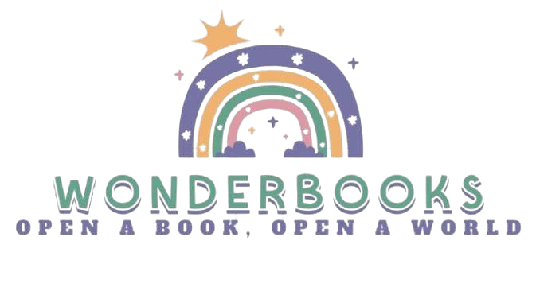

Kirsten Hartley.